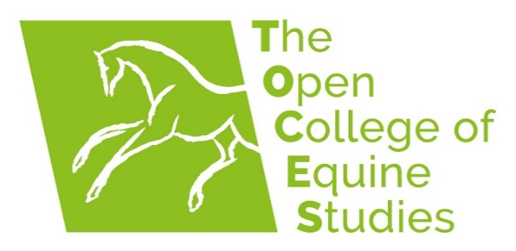

DIPLOMA IN EQUINE PHYSIOTHERAPY

ENROLMENT FORM

Oaks Meadow, Weathercock Hill, Chevington, Bury St Edmunds, Suffolk IP29 5RG

Tel: +44 (0) 1284 811 401

Email: info@equinestudies.co.uk

PERSONAL DETAILS

Please print clearly
Surname: |  |  |  | Gender: (Circle choice) Male/Female/Other/  Prefer not to say |  |  |  | Title:
Forenames: |  |  |  | Date of Birth:
 | Set out your name as you wish it to appear on your certificate:

Home Address:

Telephone: (Day)
Email: |  |  |  |  |  |  | How did you hear about The Open College of Equine Studies?

Ethnicity:

Employment status:

Unique Learner Number (ULN) if known (UK learners):
International Learners Start Date |  |  | May or September (Please circle / highlight one)

Terms and Conditions of Enrolment

Places are limited on this programme and to avoid potential student withdrawals, which would deprive another student of a place on the course, only those with a very serious interest in Equine Physiotherapy should apply. It is a big commitment financially, and in terms of time and effort.
Notwithstanding unforeseen circumstances that may occur over the 4 years of the course, tick to indicate that you understand that you must:
I understand that I will be required to pay Open Awards registration fees for each level of the course (Level 4, level 5 and level 6). Approximately £212 per level.
Attend 14 x 4-day study weeks (held in Suffolk, UK Monday – Thursday) Or:
Attend 4 x 14-day study blocks, one in each year of the programme (International students)
*Be proactive in arranging shadowing and occupational experience in Years 1, 2, 3 and 4 of the programme
Non-UK students: Understand that it is your responsibility to research and understand the legislative requirements of practicing Equine Physiotherapy in your country of residence and/or the country in which you wish to practice
In addition to attending the above listed practical training sessions, spend an average of 10 hours per week studying for four years
From the start of Year 2 of the course, take out, and pay for, personal accident, malpractice, public liability and professional indemnity insurance which is to be maintained for the duration of the programme
Upon completion of this programme, undertake career long continuing professional development
Upon graduation, sign a declaration agreeing to:
- work as part of a wider multi-professional team with due regard for the restrictions that apply under the Veterinary Surgeons Act 1966 in the UK and/or legislative requirements of the country in which you wish to practice
- practice to the extent that you have established, maintained and developed your ability to work safely and competently
- ensure you always have appropriate professional liability and indemnity insurance cover for that practice
- undertake career-long learning, continuing professional education (CPD) and development to maintain fitness to practise.

*TOCES can provide advice and guidance as to how to procure placements, but students are expected to be proactive in helping to arrange this.

Please list all post-16 academic, equestrian and other qualifications, including information about awarding bodies. Copies of the most relevant and advanced certificates must be sent in.

If English is not your first language or you have not studied the final two years of school in English, explain how you can demonstrate capability in English at a standard commensurate with IELTS 5.5:

Current occupation:

Will you continue in this, or any other, occupation whilst studying this programme?

Please explain how you will fit in the study time, including all practical work, with your career, family and other commitments. E.g. If employed please confirm how you will manage the practical attendance, e.g. annual leave. The time commitment is the most significant factor in this course – it is essential that you can dedicate the necessary time and attend all study weeks.

Please provide details of equine/veterinary/therapy experience:

Please detail your areas of specific interest in the field of equine physiotherapy:

Please outline your intended career plan upon successful completion of this programme (if intending to progress to post graduate study, you must check the entry requirements of your intended university):

Health status: please give details of any disabilities and/or health problems that may affect your ability to complete this programme:

Special requirements: please give details of any learning difficulties or special requirements that may affect your ability to complete this programme. Note that a declaration of learning difficulties or special requirements will not adversely affect your enrolment.

Personal Statement

To help us select appropriately for this programme you are required to submit a Personal Statement (max 250 words). It is up to you what information you wish to include in your statement.

PAYMENT DETAILS

Please tick relevant box and include amount payable.

Payment method | Please make payment by bank transfer (Please tick payment method selected)
Payment in Full
(£19,830)
Pay Yearly
(1x instalments of £5,950 followed by 3x yearly instalments of £4,627)
Pay as You Learn
(Initial fee of £2,974 and 45 monthly payments of £375)
*Open Award Registration Fee
£212.00 payable upon enrolment for Level 4
£212 Level 5 registration fee is payable 16 months after enrolment.
£212 Level 6 registration fees is payable 32 months after enrolment.
*Fees subject to change
International Payments:  Payment must be made in GBP Sterling and all associated bank charges paid.  Shortfalls in fees paid due to international bank charges and/or exchange rates will be notified to you and must be corrected. | The Open College of Equine Studies  Sort code: 30-95-96  Acc no: 2407 1060  IBAN: GB69 LOYD 3095 9624 0710 60  BIC: LOYDGB21380  Cite student surname in reference

TERMS AND CONDITIONS OF ENROLMENT

- The Open College of Equine Studies (TOCES) owns the copyright in all course material.
- Login details and all course materials, in whatever form, must not be copied or shared in part or in full.
- TOCES’ policy is one of continuous improvement; accordingly, TOCES reserves the right to alter and update course material without notice at any time.
- Where a course is in the process of being updated or revised, the modules will be made available to you as they become available.
- You agree to accept the terms and conditions set out in TOCES Learner Agreement and Withdrawal Policy.
- Additional costs may be incurred to cover the increase in tutor fees and a fee to cover increased Study Week/Block costs if Study Weeks/ Blocks are not attended within the advised time scale and an extension is granted as detailed in the Course Completion and Extension Policy.
- If TOCES cancels your course/programme of learning for whatever reason, refunds will be limited to fees paid.
- Your information will be shared with Open Awards, the relevant regulatory body, to complete your registration.

DECLARATION

I confirm I have read the document “EQUINE PHYSIOTHERAPY DIPLOMA PROGRAMME LEARNER AGREEMENT AND WITHDRAWAL POLICY” and accept the Terms and Conditions therein.

* Student Signature: |  | Date:
Signature of person responsible for payment of course fees if not student |  | Date:
* Student must sign, regardless of who is paying the course fees

TOCES OFFICE USE
Date enrolment  received | Payment method and  amount | Date course access enabled | Student enrolment  number | Notes

